H.U. MECHANICAL ENGINEERING

GENERAL CHEMISTRY LAB REPORT

ACID BASE TİTRATİON

GÖKAY KART

KIM-121-6

CANAN ARMUTÇU

Aim

The aim of this experiment is to find the concentration of an acid or base of unknown concentration with the aid of titration.

What is the titration?

The process of determining the concentration of an acid or base using a neutralization reaction.

What is the indicator ?

It is a weak acid or base that changes color when it reaches the equivalence point .

What is the analyte?

The solution whose concentration has to be determined.

What is the titrant?

It is an acid or base whose concentration is known in the neutralization reaction.

What is the endpoint?

Refers to the point at which the indicator changes color in an acid-base titration.

What is the equivalence point?

It is the neutral equilibrium point reached with the titrant added to the solution.

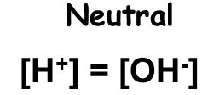

What is the important point?

pH increases slowly far from the equivalence point and pH changes quickly near the equivalence point.

**The equivalence point of a strong acid - strong base titration = 7.00**

What is the pH curve?

Adding titrant - plot of pH change

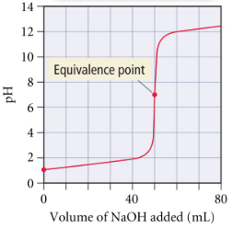

Strong Acid & Strong Base Titration

The pH of the equivalence point is very close to 7.00. Its steep ascent range is evident.

Weak Acid-Strong Base Titration

The pH at the equivalence point is greater than 7.00. The steep rise interval is less pronounced.

Weak Base with a Strong Acid Titration

The pH at the equivalence point is less than 7.00. The steep rise range is less pronounced.

When should we stop the titration?

It should be stopped as soon as the color change appears.

Which color is more correct?

The ideal solution is on the left.

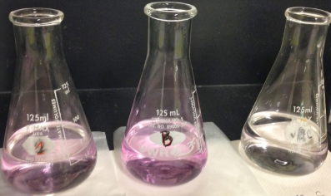

Balance in solutions

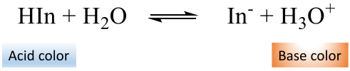

* Increasing the H3O+ concentration shifts the balance to the left. HIn ratio increases and acid color occurs.
* Decreasing the H3O+ concentration shifts the balance to the right. In-rate increases and base color is formed.

Data of the experiment;

1.Step

Concentration of standard acid 🡪 0.05 M

Volume of standard acid 🡪 5 mL

Volume of NaOH used 🡪 3.7 mL

2.Step

Volume of unknown acid 🡪 5 mL

Volume of NaOH used 🡪 6.5 mL

Calculations of the experiment;

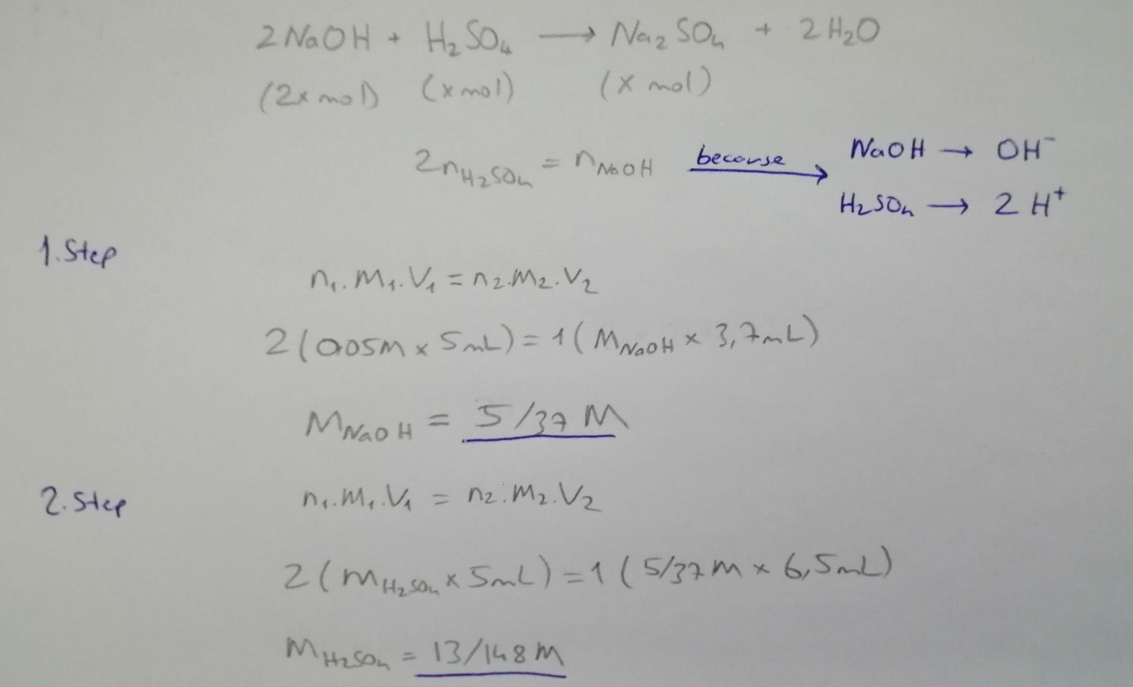

Results of the experiment;

Concentra0on of NaOH used 🡪 5/37 M

Concentra0on of unknown acid 🡪 13/148 M

Discussion part of the experiment;

In the experiment, it was aimed to make the titration using H2SO4 and NaOH.

In the first experiment, 25 ml of water was mixed with the standard H2SO4 solution of known molarity. 2 drops of phenolphthalein were added. We reached the endpoint when 3.7 mL of NaOH was added to the solution.

As a result, we found the molarity of NaOH. The solution formed in the first experiment was very pink in color. This color is too much value for a titration.

In the second experiment, 25 ml of water was mixed with H2SO4 solution of unknown molarity. 2 drops of phenolphthalein were added. We reached the end point when 6.5 mL of NaOH was added to the solution (we know its molarity from experiment 1).

As a result, we found the molarity of H2SO4. The solution formed in the second experiment was slightly pink in color. This color is ideal for a titration.

In a titration experiment;

* Adding should be done slowly.
* After each addition, the solution should be shaken.
* Choosing the right indicator should be done.
* Titration should stop at the endpoint according to the color of the indicator used.
* Correct observation is important.
* The amount of substance added from the burette must be calculated correctly.
* The H + and OH- coefficients of the acid and base used must be calculated correctly.

When these factors are observed, an accurate titration experiment will be performed.

Questions & Answers:

1-What is the difference between equivalence and end point?

* The equivalence point is a point where the chemical reaction ends.
* The end point is the point where the color change occurs in a system.

2-In this solution, which indicators can be used instead of phenolphthalein in order to determine the end point?

* Indicators that show a clear color change from acidic environment to basic environment should be used. For example, Bromthymol blue can be used for this solution because there is a clear transition from yellow to blue.

Referenced sources:

Websites:

<https://tr.wikipedia.org/>

<https://www.greelane.com/>

Books:

General Chemistry Principles and Modern Applications (10th Edition, Chapter 17).